5.2 Cloud Automation and System Workflows (n8n Integration)
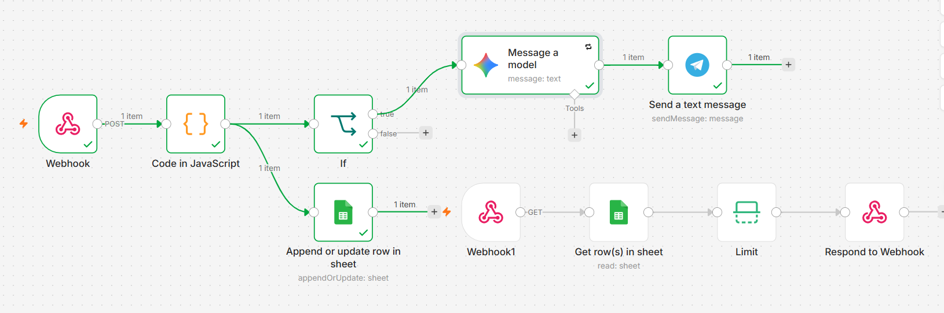
Workflow 2
Workflow 1
The cloud infrastructure of the LifeGuard system is orchestrated using n8n, an advanced, event-driven workflow automation platform. n8n was selected due to its capability to handle real-time data streams with minimal latency, its robust data parsing abilities, and its seamless integration with third-party APIs. To ensure high performance and prevent data congestion, the cloud architecture is divided into two independent asynchronous workflows.

5.2.1 Workflow 1: Data Ingestion, Archiving, and Emergency Triage
This primary workflow is dedicated to receiving continuous telemetry from the ESP32, logging the data, and dispatching instant alerts during critical events.

A. The Entry Point: Webhook Trigger (POST)
The workflow is initiated by a Webhook Node configured to receive HTTP POST requests from the ESP32 every two seconds. To optimize edge device performance, the node is set to respond immediately (Respond Immediately), ensuring the microcontroller's execution loop is never blocked by cloud latency.

B. Algorithmic Data Processing (JavaScript Code Node)
Raw JSON payloads transmitted by edge devices require sanitization and mathematical processing before logging. A custom JavaScript Code Node is implemented to convert raw inputs into float values, handle potential null data (to prevent system crashes), and calculate the Net Acceleration Vector using the formula: $\sqrt{x^2+y^2+z^2}$.

Code Snippet X.1: JavaScript logic for data sanitization and fall detection thresholding.
JavaScript
// Retrieve the incoming JSON payload from the Webhook
const payload = $input.item.json.body || $input.item.json;

// Sanitize sensor data (defaulting to 0 if null)
const bodyTemp = parseFloat(payload.temp_obj) || 0;
const acc_x = parseFloat(payload.acc_x) || 0;
const acc_y = parseFloat(payload.acc_y) || 0;
const acc_z = parseFloat(payload.acc_z) || 0;
const heart_rate = parseInt(payload.heart_rate) || 0;
const spo2 = parseInt(payload.spo2) || 0;
const ecg_raw = parseInt(payload.ecg_raw) || 0;
const ecg_status = payload.ecg_status || "Unknown";

// Calculate Net Acceleration Vector
const netAcc = Math.sqrt((acc_x * acc_x) + (acc_y * acc_y) + (acc_z * acc_z));

// Initialize states
let motion_state = "Stable";
let is_emergency = false;

// Apply medical and physical thresholds
if (netAcc > 25.0 || heart_rate > 120 || (heart_rate < 40 && heart_rate > 0) || spo2 < 90) {
motion_state = (netAcc > 25.0) ? "FALL DETECTED!" : "Critical Vitals";
is_emergency = true;
} else if (netAcc > 16.0) {
motion_state = "Abnormal Shaking";
} else if (netAcc >= 7.5 && netAcc <= 12.5) {
motion_state = "Stable";
} else {
motion_state = "Moving";
}

// Forward the processed payload
return {
json: {
timestamp: new Date().toISOString(),
temperature: bodyTemp.toFixed(1),
heart_rate: heart_rate,
spo2: spo2,
ecg_raw: ecg_raw,
ecg_status: ecg_status,
net_acceleration: parseFloat(netAcc.toFixed(2)),
motion_state: motion_state,
is_emergency: is_emergency
}
};

C. Historical Archiving (Google Sheets)
The sanitized data is systematically routed to a Google Sheets Node (configured to 'Append Row'). This acts as a highly accessible Electronic Health Record (EHR), allowing doctors to review historical patient data.

D. AI-Assisted Triage and Caregiver Notification
An IF Node continuously evaluates the is_emergency boolean flag. If True, the workflow triggers the emergency sequence:
- Gemini AI Node: The critical vital signs are passed to a Large Language Model instructed through specific Prompt Engineering to act as a triage assistant.
Prompt used for AI Triage:
"You are an expert emergency medical triage assistant for the LifeGuard System. An emergency alert has just been triggered. Patient vitals: HR {{ $json.heart_rate }} BPM, SpO2 {{ $json.spo2 }}%, Temp {{ $json.temperature }}°C, Motion: {{ $json.motion_state }}. Write a highly urgent, clear, and actionable first-aid instruction for the caregiver in maximum two sentences. Do not include conversational text."
- Telegram API Node: The generated AI directive is immediately pushed to the designated caregiver's mobile phone via a Telegram Bot, ensuring zero-latency response.

5.2.2 Workflow 2: Mobile Application REST API
To serve the LifeGuard mobile dashboard without causing application crashes due to massive data payloads, a secondary n8n workflow operates as a customized REST API.
- API Endpoint (Webhook GET): The mobile application sends a GET request to a dedicated endpoint. Crucially, the connection is held open (Using 'Respond to Webhook' Node) while the server processes the data.
- Data Fetching & Optimization: A Google Sheets Node fetches the entire EHR database. To eliminate latency, an Item Lists Node (Limit Operation) is deployed to filter the array, retaining strictly the last row (the most recent telemetry).
- Delivery (Respond to Webhook): The optimized, single-object JSON payload is returned through the open connection directly to the mobile application, ensuring a lightweight and highly responsive user interface.

